**Expert ID/Name: Nstructive**

**Date:**

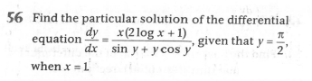

**Answer:**

|  |
| --- |
| **Section 1:** Algorithm/Theorem Reminder / A tip for solving these type of questions |
| **Tips:**   1. Separate the terms of. 3. Substitute in the general solution of . |

|  |
| --- |
| **Section 2:** Step-by-step answer |
| Given: Differential equation is ,  To find: Particular solution of ,given that  Step 1:   |  |  | | --- | --- | | Instruction | Separate the terms of . | | Calculation |  |   Step 2:   |  |  | | --- | --- | | Instruction: | Apply the integration on both sides with respect to x. | | Calculation: | In      In |   Step 3:   |  |  | | --- | --- | | Instruction: | Now, substitute  in | | Calculation: | Hence the particular solution is . | |

|  |
| --- |
| **Section 3:** |
| Final answer: Particular solution of differential equation ,  is.  Hence, verified. |